|  |
| --- |
| **Ability Enhancement Course: Web Designing using PHP and MySQL** |
| **PART A** |
| **Module-1** |
| **Introduction to PHP:** PHP features, XAMPP & WAMP, Installation of XAMPP, Basic PHP Syntax, Output Statements- print, echo, Adding comments in PHP. **PHP Variables and Operators:** Declaring Variables, Operators in PHP. **Conditional and Looping Statements:** If...Statement, Switch, For, Foreach, While, Do while.  **Assignments:**  1. Write a program to check student grade based on the marks using if-else statement.  **Conditions:**   * If marks are 60% or more, grade will be First Division. * If marks between 45% to 59%, grade will be Second Division. * If marks between 35% to 45%, grade will be Third Division. * If marks are less than 35%, student will be Fail.     **Program:**    <?php  $sub_1=95;  $sub_2=85;  $sub_3=74;  $sub_4=64;  $sub_5=53;    $total=NULL;  $average=NULL;  $percentage=NULL;  $grade=NULL;    $total=$sub_1+$sub_2+$sub_3+$sub_4+$sub_5;    $average=$total/5.0;    $percentage=($total/500.0)*100; if ($average>=60)  $grade='A';    else if ($average>=45 && $average<59)  $grade='B';  else if($average>=35 && $average<45)  $grade='C';    else  $grade='Fail';    echo "The Total marks =".$total."/500\n"; echo "The Average marks=".$average."\n"; echo "The Percentage =".$percentage."%\n"; echo "The Grade =".$grade."\n";    ?> |

|  |
| --- |
| **Output:** |
| **Module-2** |
| **Functions:** User defined functions, Function with Default Arguments, Passing Argument by Reference, Passing Argument by Value, Variable Scope, Built-in functions. **Strings:** Strings in PHP, String functions in PHP. **Arrays:** Types of arrays in PHP, Creation of arrays, Array functions.  **Assignments:**  2. Write a PHP program to display a digital clock which displays the current time of the server.  **Program:**  <!DOCTYPE html>  <html>  <body>    <?php echo "Today is :".date("Y/m/d")."<br>"; date_default_timezone_set("Asia/kolkata"); echo "Current time is : ".date("h:i:s a");  ?>  </body>  </html>    **Output :** |

|  |
| --- |
| 3. [**Write a simple calculator program in PHP using switch case**](https://tutorialsclass.com/exercise/simple-calculator-program-in-php/) **Program:**  <!DOCTYPE html>  <head>  <?php  $first_num = $_POST['first_num'];  $second_num = $_POST['second_num'];  $operator = $_POST['operator'];  $result = '';  if (is_numeric($first_num) && is_numeric($second_num))  { switch ($operator)  { case "Add":  $result = $first_num + $second_num; break; case "Subtract":  $result = $first_num - $second_num; break; case "Multiply":  $result = $first_num * $second_num; break; case "Divide":  $result = $first_num / $second_num;  }  }    ?>    <body>  <div id="page-wrap">  <h1>PHP - Simple Calculator Program</h1>  <form action="" method="post" id="quiz-form"> |

p

>

<

<

input type="number" name="first_num" id="first_num" required="required" val

-

ue="<?php echo $first_num; ?>" /> <b>First Number</b>

<

/p

>

<

p

>

<

input type="number" name="second_num" id="second_num" required="required" val

-

ue="<?php echo $second_num; ?>" /> <b>Second Number</b>

>

<

/p

<

p

>

<

input

readonly="readonly"

name="result"

value="<?php

echo

$result;

?>">

>

<

b>Result</b

<

>

/p

>

<

input type="submit" name="operator" value="Add" /

<

input type="submit" name="operator" value="Subtract" /

>

input type="submit" name="operator" value="Multiply" /

>

<

>

input type="submit" name="operator" value="Divide" /

<

<

/form

>

<

/div

>

<

/body

>

<

/html

>

**Output**

**:**

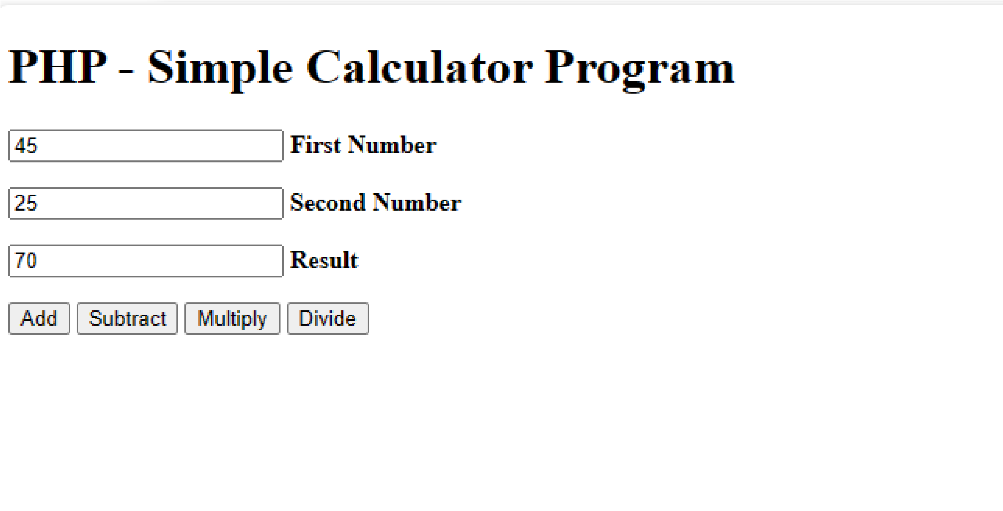

|  |
| --- |
| **Description:**  You need to write a simple calculator program in PHP using switch case. **Operations:**1.Addition 2. Subtraction 3. Multiplication 4. Division |
| **Module-3** |
| **File Handling:** File opening modes, File Open/Read, File Create/Write, Delete a File. **Pattern Matching:** String pattern matching using regular expressions. **PHP Form Handling:** Input Form Creation, GET and POST Methods, include() and require().  **Assignments:**  4. Write a PHP program to keep track of the number of visitors visiting the web page and to display this count of visitors, with proper headings.  **Program:**    <?php echo "<h1> REFRESH PAGE </h1>";  $file='count.txt';  $c=file_get_contents($file); file_put_contents($file,$c+1); echo "The number of users visited:".$c;  ?>    **Output:** |
| **Module-4** |
| Cookies and Sessions:Cookies, PHP support for cookies. Starting a PHP Session, Storing and Accessing Session Data, Destroying Session Data.  MySQL: Introduction, Database creation, CREATE, ALTER, DELETE, DROP tables, INSERT, UPDATE, DELETE table data, WHERE clause AND, OR, IN, LIKE, DISTINCT, ORDER BY, GROUP BY, UNION Sub-queries LEFT JOIN, RIGHT JOIN, INNER JOIN. Assignments:  5. Write a PHP program named states.py that declares a variable states with value “Karnataka Ta- |

|  |
| --- |
| milNadu Kerala AndraPradesh. write a PHP program that does the following:   1. Search for a word in variable states that ends in xas. Store this word in element of a list named states List. 2. Search for a word in states that begins with T and ends in u. Perform a case-insensitive comparison. [Note: Passing re.Ias a second parameter to method compile performs a case-insensitive comparison.] Store this word in element1of states List.      1. Search for a word in states that begins with K and ends in a. Store this word in element 2 of the list. 2. Search for a word in states that ends in a. Store this word in element 3 of the list.   **Program:**  <html>  <body>  <?php  $states="Karnataka TamilNadu Kerala AndraPradesh";  $b = explode(' ',$states);  echo "<br>ORIGINAL ARRAY:<br>";    foreach ($b as $i=>$value){ echo "states[$i]=$value<br>";  } $d=[];  foreach ($b as $c)  {  $n=strlen($c);      if($c[$n-1]=='s' && $c[$n-2]=='a' && $c[$n-3]=='x') $d[0]=$c; if($c[0]=='K' && $c[$n-1]=='s') $d[1]=$c; if($c[0]=='T' && $c[$n-2]=='s') $d[2]=$c; if($c[0]=='K' && $c[$n-3]=='s') $d[3]=$c; if($c[0]=='A' && $c[$n-4]=='s') $d[4]=$c; if($c[0]=='T' && $c[$n-3]=='a') $d[]=$c;  }  echo "<br>RESULTANT ARRAY :<br>";  for($i=0;$i<count($d);$i++){ |

|  |
| --- |
| echo "statesList[$i]=$d[$i]<br>";  }  ?>  ?>    </body>  </html>  **Output:** |
| Module 5 |
| Database Programming PHP & MySQL: PHP MySQL functions, Connecting database.  Assignments:  6. Write a PHP program to sort the student records which are stored in the database using selection sort.  **Program:**  <?php  $servername = "localhost";  $username = "root";  $password = "";  $dbname = "student";  $conn = mysqli_connect($servername, $username, $password, $dbname); if (!$conn) { die("Connection failed: " . mysqli_connect_error());  }  $sql = "SELECT * FROM studentinfo"; |

|  |
| --- |
| $result = $conn->query($sql);  $usn = array() ; echo "<table border='2'><caption>Before Sorting </caption><br>"; echo "<tr><th>USN</th><th>NAME</th><th>ADDRESS</th></tr>"; if ($result->num_rows > 0)  {  while($row = $result->fetch_assoc())  {  echo "<tr><td>". $row["usn"]."</td>"; echo "<td>". $row["name"]."</td>"; echo "<td>". $row["address"]."</td></tr>"; $usn[] = $row["usn"] ;  }  }  $n = sizeof($usn) ; for($i = 0 ; $i < $n-1 ; $i++ )  {  $pos = $i ; for($j = $i + 1 ; $j < $n ; $j++ )  { if( $usn[$pos] > $usn[$j])  {  $pos = $j ;  } }  if( $pos != $i)  {  $temp = $usn[$i] ;  $usn[$i] = $usn[$pos] ;  $usn[$pos] = $temp ;  }  }  $name = [] ;  $address = [] ;  $result = $conn->query($sql); if ($result->num_rows> 0) |

|  |
| --- |
| {  while($row = $result->fetch_assoc())  {  for($i=0;$i<$n;$i++)  {  if($row["usn"] == $usn[$i])  {  $name[$i]=$row["name"];  $address[$i]=$row["address"];  }  }  }  }  echo "<br><br>"; echo "<br><table border='2'><caption>After Sorting</caption><br>"; echo "<tr><th>USN</th><th>NAME</th><th>Address</th></tr>"; for($i=0;$i<sizeof($usn);$i++)  {  echo "<tr><td>".$usn[$i]."</td>"; echo "<td>".$name[$i]."</td>"; echo "<td>".$address[$i]."</td>";  }  ?>      **Output:** |

|  |  |  |  |  |  |  |  |  |  |  |  |  |  |  |  |  |  |  |  |  |
| --- | --- | --- | --- | --- | --- | --- | --- | --- | --- | --- | --- | --- | --- | --- | --- | --- | --- | --- | --- | --- |
|  | | | | | | | | | | | | | | | | | | | | |
| **PART B** | | | | | | | | | | | | | | | | | | | | |
| **Using the knowledge from the above programs prepare a mini project and demonstrate.** | | | | | | | | | | | | | | | | | | | | |
| **AssessmentDetails (both CIE andSEE)** | | | | | | | | | | | | | | | | | | | | |
|  | | **Component** | | | | | | | | | | | **Weightage(%)** | | | | |  | | |
| **CIE’s** | | | | CIE1 5thweek | | | | | | | 20 | | | 60 | |
| CIE2 10thweek | | | | | | | 20 | | |
| CIE315thweek | | | | | | | 20 | | |
| **AAT’s** | | | | AAT-1 10thweek | | | | | | | 10 | | | | |
|  | | | | AAT-2 | | | | | | | 10 | | | | |
|  | | | | AAT-3 | | | | | | | 20 | | | | |
| **ContinuousInternalEvaluationTotalMarks:100.Reducedto50Marks** | | | | | | | | | | | | | | | |
| **SemesterEndExamination(SEE)TotalMarks:100.Reducedto50**  **Marks** | | | | | | | | | | | | | | | |
| **Text Books:**  1. Programming the World Wide Web, Robert W. Sebesta, Pearson Education, 8th Edition, 2014. | | | | | | | | | | | | | | | | | | | | |
| **Reference Book:**   1. Internet & World Wide Web How to program, M. Deitel, P.J.Deitel, A. B. Goldberg, Pearson Education / PHI, 3rd Edition, 2004. 2. Web Programming Building Internet Applications, Chris Bates, Wiley India. | | | | | | | | | | | | | | | | | | | | |
| **Course Outcomes:**  At the end of the course the student will be able to:  **CO1.** Develop dynamic webpages using basic concepts of PHP. **CO2.** Apply Cookies and Sessions to control user sessions **CO3.** Demonstrate various MySQL database queries.  **CO4.** Develop small applications using PHP/MySQL. | | | | | | | | | | | | | | | | | | | | |
| **POs** | **CO-PO Mapping** | | | | | | | | | | | | | | | | | | | |
| **COs** | **PO1** | | **PO2** | **PO3** | **PO4** | | **PO5** | **PO6** | **PO7** | **PO8** | **PO9** | **PO10** | | **PO11** | **PO**  **12** | | **PSO1** | | **PSO2** | **PS O3** |
| **CO1** | 3 | | 2 |  |  | |  |  |  |  |  |  | |  |  | | 2 | |  | 3 |
| **CO2** | 3 | | 2 |  |  | |  |  |  |  |  |  | |  |  | |  | |  | 1 |
| **CO3** | 3 | | 2 | 3 | 3 | | 2 |  |  |  |  | 1 | | 2 |  | | 2 | |  | 3 |
| **CO4** | 3 | | 2 | 3 | 3 | | 3 |  | 3 | 3 | 2 | 3 | | 3 |  | | 3 | |  | 3 |